Tabari Harvey Module 6.2 Assignment

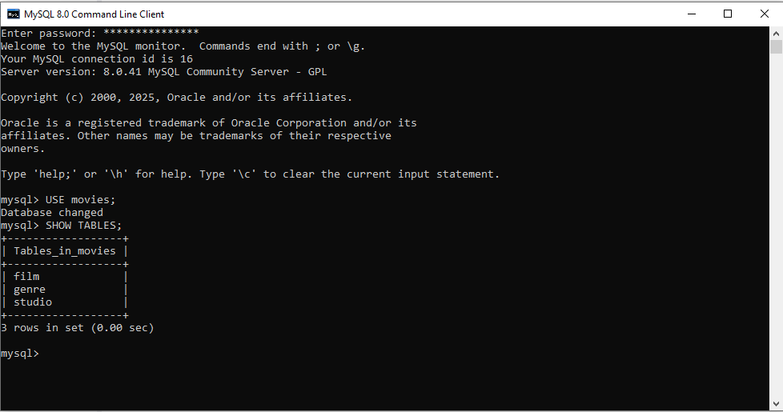

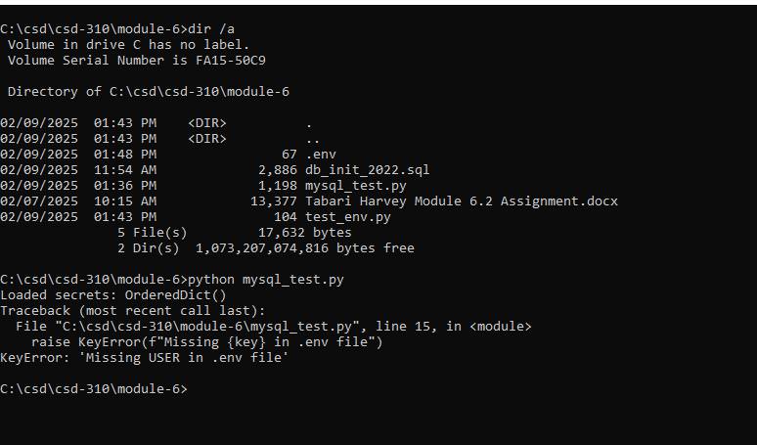

I could not understand how my file was not reading in the code. I re did the code, I retyped the code, I used a test and the file import worked with dotenv_values. I tried for hours to get this to read the script but this is all I could get.